Group Members: Shangzhou Xia, Chunyue Xu

Potential name of our website: G·alaxy

Proposal

For this group assignment, we are planning on building a website that consists of different types of resources for people that are interested in getting started in the field of gaming. Resources such as guides created by ourselves and the once created by the developers themselves will take up the majority of our website. Videos, artworks, wiki pages and even twitch live streams will also be included to assist those that are completely new to gaming. We want to make the website to be interactive in order to fit the user’s needs. Technical features such as filtering out 18+ content, resizing images or videos, animation of website panels and maybe some creative ways of taking the users to the destinations they want to go will be included. We would also want implement a search engine of our own that could search available game guides by both keyword and genre such as FPS, RPG, Indie, MOBA etc. It is going to be a-lot of work to make a guide for every single game on the market, so it will be the best that we stick to the current gen AAA titles or games with a high rating. General guides for building a gaming pc and definitions of each genre are also helpful guides to have beside the specific game guides. We look forward to learn the skills required to do the above in class.

Navigation plan:

“Introction to games” will be shown as “Menu” in the home page.

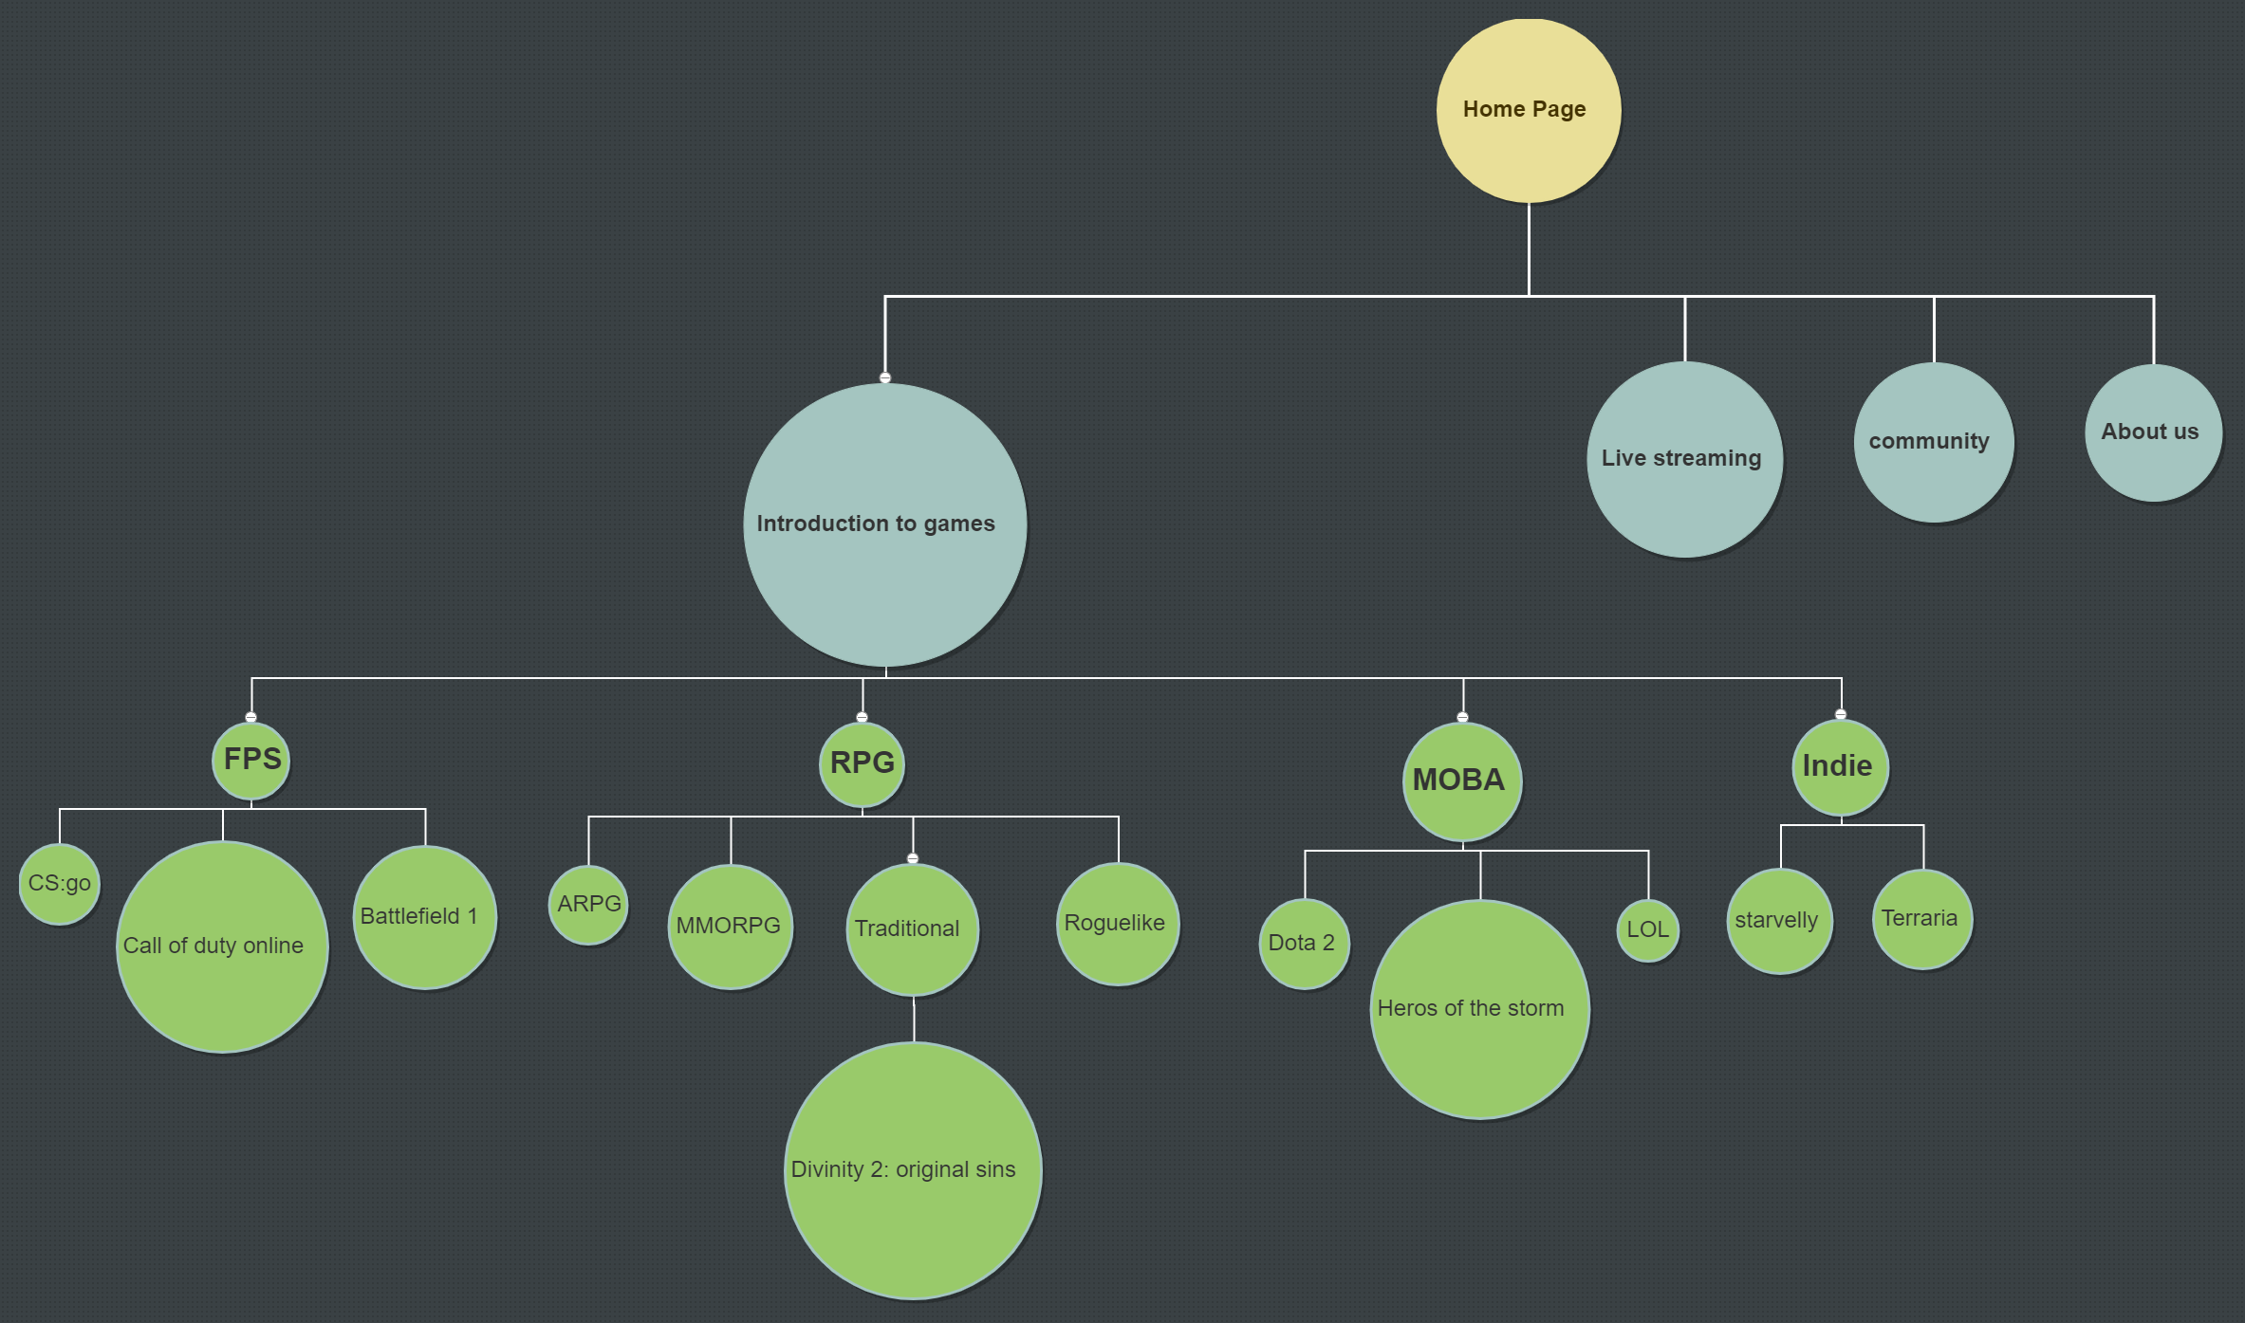

Layout Plan:

Home page

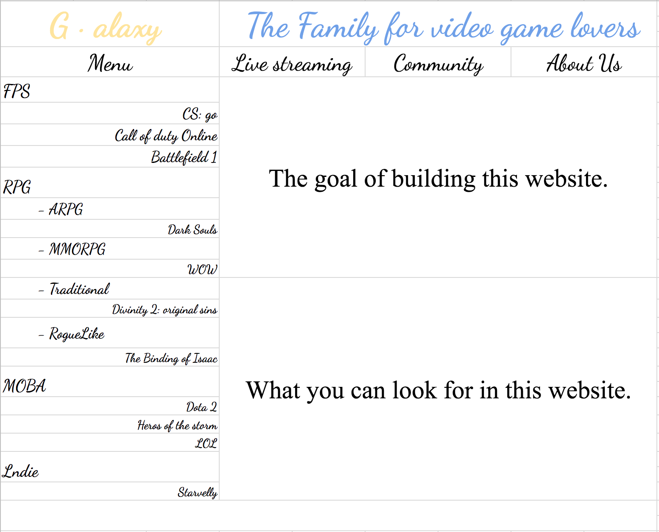

other webpage:

1. In every page, when you click “G · alaxy” and “The Family for video game lovers”, you will back to the home page.
2. There will be a taskbar in the webpages expect the home page.
3. Move your mouse to “Introduction to game”, then you will see the menu the same as the one in the home page.

